CS 461

Lab Assignment 4

Name: Gandhi Dhruv Vipulkumar

Institute ID: 202151053

Date: 23-9-2024

**Q. Implement Java RMI (Remote Method Invocation)**

**Basic To Do List:**

**ToDoListInterface.java**

import java.rmi.Remote;  
import java.rmi.RemoteException;  
import java.util.List;  
  
public interface TodoListInterface extends Remote {  
    void addTask(String task) throws RemoteException;  
  
    void removeTask(String task) throws RemoteException;  
  
    List<String> listTasks() throws RemoteException;  
}

**ToDoListImplementation.java**

import java.rmi.RemoteException;  
import java.rmi.server.UnicastRemoteObject;  
import java.util.ArrayList;  
import java.util.List;  
  
public class TodoListImplementation extends UnicastRemoteObject implements TodoListInterface {  
    private List<String> tasks;  
  
    protected TodoListImplementation() throws RemoteException {  
        super();  
        tasks = new ArrayList<>();  
    }  
  
    @Override  
    public void addTask(String task) throws RemoteException {  
        tasks.add(task);  
    }  
  
    @Override  
    public void removeTask(String task) throws RemoteException {  
        tasks.remove(task);  
    }  
  
    @Override  
    public List<String> listTasks() throws RemoteException {  
        return tasks;  
    }  
}

**ToDoListServer.java**

import java.rmi.registry.LocateRegistry;  
import java.rmi.registry.Registry;  
  
public class TodoListServer {  
    public static void main(String[] args) {  
        try {  
            TodoListImplementation obj = new TodoListImplementation();  
  
            Registry registry = LocateRegistry.createRegistry(2000);  
            registry.rebind("TodoListService", obj);  
  
            System.out.println("To-Do List Server is ready.");  
        } catch (Exception e) {  
            e.printStackTrace();  
        }  
    }  
}

**ToDoListClient.java**

import java.rmi.registry.LocateRegistry;  
import java.rmi.registry.Registry;  
import java.util.List;  
import java.util.Scanner;  
  
public class TodoListClient {  
    public static void main(String[] args) {  
        try {  
            // Locate the registry  
            Registry registry = LocateRegistry.getRegistry("localhost", 2000);  
  
            // Look up the remote object  
            TodoListInterface stub = (TodoListInterface) registry.lookup("TodoListService");  
            Scanner scanner = new Scanner(System.in);  
            String command;  
  
            System.out.println("Welcome to the To-Do List application!");  
            do {  
                System.out.println("Enter a command (add, remove, list, exit):");  
                command = scanner.nextLine();  
  
                switch (command.toLowerCase()) {  
                    case "add":  
                        System.out.println("Enter task to add:");  
                        String taskToAdd = scanner.nextLine();  
                        stub.addTask(taskToAdd);  
                        System.out.println("Task added.");  
                        break;  
                    case "remove":  
                        System.out.println("Enter task to remove:");  
                        String taskToRemove = scanner.nextLine();  
                        stub.removeTask(taskToRemove);  
                        System.out.println("Task removed.");  
                        break;  
                    case "list":  
                        List<String> tasks = stub.listTasks();  
                        System.out.println("Current tasks:");  
                        for (String task : tasks) {  
                            System.out.println("- " + task);  
                        }  
                        break;  
                    case "exit":  
                        System.out.println("Exiting application.");  
                        break;  
                    default:  
                        System.out.println("Invalid command. Try again.");  
                }  
            } while (!command.equalsIgnoreCase("exit"));  
  
            scanner.close();  
        } catch (Exception e) {  
            e.printStackTrace();  
        }  
    }  
}

**Code Explanation:**

* A remote interface is declared that declares remote methods such as addTask, removeTask, listTasks.
* Then implemented remote interface in ToDoListImplementation.java
* The To do list server is hosted on localhost with port 2000.
* The client successfully connect to the server and can run the To do list application.

**Testing Phase:**

**1) Adding three task(shopping, CS461 lab4 assignment, lab submission)**

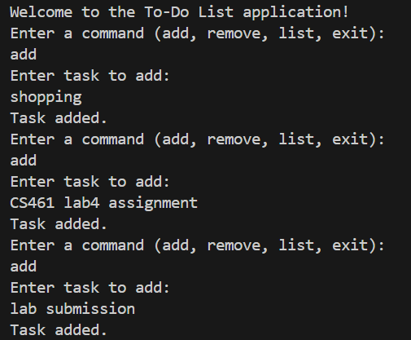

**2) View List**

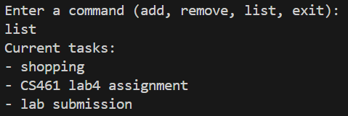

**3) Remove ‘shopping’ from the list**

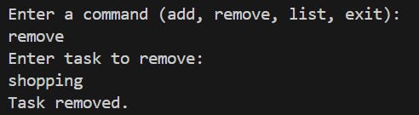

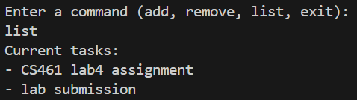

**Conclusion:** Implemented Java RMI successfully with To Do List application.